Protecting Habitat and History

A 2005 Progress Report Responding to
Section 3(c) of Executive Order 13287, “Preserve America”

U.S. Department of the Interior
U.S. Fish and Wildlife Service
September 2005
Table of Contents

Introduction

Report Organization

Program Progress
(addresses Executive Order questions 10, 10a, 10b, and 10c)

Heritage Tourism Development

(addresses Executive Order questions 10d and 10e)

Future Recommendations

(addresses Executive Order questions 10f)

Each agency with real property management responsibilities shall, by September 30, 2005, and every third year thereafter, prepares a report on its progress in identifying, protecting, and using historic properties in its ownership.

Section 3(c), Executive Order 13287

Introduction

In March 2003, the President issued Executive Order 13287 (E.O.) to reaffirm our nation’s commitment to preserving heritage resources while assessing Federal land management agencies’ approaches to overseeing and managing these important assets. In September 2004, the U.S. Fish and Wildlife Service (FWS) submitted its report to the Advisory Council on Historic Preservation (ACHP) as required by Section 3 of the E.O. That report detailed the FWS’ efforts to preserve heritage resources and promote their use, where applicable, for tourism, interpretation, and education.

In keeping with Section 3(c) of the EO, the FWS offers the following update and highlights on initiatives involving the protection and use of heritage resources.

How is the FWS involved in managing historic resources?

The FWS is clearly recognized as a leader in conserving wildlife and natural habitats. However, most people are unaware that national wildlife refuges and national fish hatcheries also protect many of our country's most important archaeological and historic sites and are home to many significant museum collections.

The FWS's manages nearly 100 million acres of land as part of the National Wildlife Refuge System. These lands are geographically diverse and spread from Maine to Guam and from the northern reaches of Alaska to the tropical Caribbean Sea. This network of lands and associated facilities are located along coasts, rivers, estuaries, and wetlands—areas that people have used for thousands of years for their homes, transportation, and subsistence.

Nearly 40 million people visited national wildlife refuges in Fiscal Year 2004 to experience the natural world, take advantage of wildlife-dependent recreation, and partake in educational and interpretive activities—many of which included programs and information about our history and the protection of historic properties.

Report Organization

This report is organized as follows:

Program Progress

Preservation in Action

- Future Directions

This report addresses the following specific issues as outlined in the E.O.’s guidelines that have been developed by the ACHP:

- Describe significant changes have occurred since the submission of your last Section 3 report with regard to the inventory, condition, and management of historic properties.

- Provide quantitative data to demonstrate the progress that has been made since the last report.

- Describe additional resources that have been allocated to integrate and better administer the agency’s preservation program.

- Describe any procedures for supporting local economic development in heritage tourism.

- Describe how findings and conclusions set forth in the previous report were useful to the agency in assessing its stewardship of historic properties.

- Provide any recommendations regarding how Executive Order 13287 Section 3 can be made more useful to the FWS.

How does the FWS define heritage resources as used in this report?

The FWS uses four categories of properties to respond to the Executive Order’s general requirements. Examples of each are provided as part of this report. These categories are:

- historic buildings, structures, and sites.
- historic trails or similar historic properties that cover broad landscapes.
- archaeological resources
- museum collections

The protection and management of these resources are required by numerous laws, regulations, and Department of the Interior policies and standards. Historic resources contribute to the public good by enriching visitors’ experiences through education and interpretive programs, building strong relationships with communities and partners, promoting scientific research, and creating economic benefits.

I. Program Progress

The FWS continues its program to comply with a wide-ranging set of laws, regulations, policies, and standards that address the management of heritage resources. Most of the work performed by the FWS’ professionals (archaeologists, museum curators and historians) relates directly to compliance with the National Historic Preservation Act’s (NHPA) Section 106 process. Section 106 requires Federal agencies to a) review and take into account the effects of projects on historic properties and b) make reasonable efforts to protect historic properties from being damaged by Federally-approved or funded projects. This work results in the discovery of new historic properties under the FWS’ control each year. Information on historic properties is reported through the FWS Operational Plan and Refuge Annual Performance Plan.

The FWS also perform a variety of projects that meet the intent and spirit of Sections 110 and 111 of the NHPA, which direct agencies to take actions to minimize harm to important historic properties and promote the preservation and use of such properties for current activities. This type of work occurs at a slower pace dependent upon available funding and partnership opportunities, but continues to gain greater visibility as FWS field stations recognize the importance of historic properties in building community relationships and maintaining important traditions and values.

The FWS is also reviewing its national policies and guidance for updating. The policies were last published in 1992 and need revision to reflect new cultural resource requirements pertaining to Section 106 compliance and protection of properties under the Archaeological Resources Protection Act (ARPA). Additionally, the FWS Operational Plan and Refuge Annual Performance Plan, which are step-downs of the Department of the Interior (Department) Strategic Plan, were launched in FY 2005. These plans include a resource protection objective that includes performance measures on managing and protecting heritage resources (See Table 1). These measures will help gauge the effectiveness of FWS’ efforts to account for and protect significant heritage resources.

Table 1. FWS Operational Plan Performance Goals for Heritage Assets
Asset | Performance Measure
Historic Structures | Number of historic structures in RPI (i.e. valued greater that 5k)
Historic Structures | Number of historic structures in RPI (i.e. valued greater than 5k) that are being monitored
Cultural Resources | Number of other cultural resources (i.e. historic structures, archaeological sites, etc) not in RPI (i.e. valued less that 5k)
Cultural Resources | Number of other cultural resources (i.e. historic structures, archaeological sites etc) not in RPI (i.e. valued less that 5k) that are being monitored
Museum Property | Total Number of Museum Property collections
Museum Property | Total Number of Museum Property collections in Good condition
Paleontological Sites | Total Number of known Paleontological sites
Paleontological Sites | Total Number of known Paleontological sites in Good condition

Data on Historic Buildings, Structures and Sites

Structures owned by FWS, including historic structures, are listed in the Real Property Inventory (RPI) database system, which will soon be replaced with the FWS’ Asset Management and Maintenance System (SAMMS). The new database will track historical status and condition information for the structures (historical status is synonymous with National Register of Historic Places designations) and document maintenance funding allocated for stabilization of a structure. The allocation is based on Regionally-assigned priorities that are adjustable, especially in the case of emergency situations affecting particular structures. Stabilization of historic structures can also be accomplished by using funds from other sources, such as grants and technical assistance donated by partners.

Data on Archaeological Resources

In FY 2005, the FWS evaluated a new geographical information system (GIS) based data tool that was launched previously. Several regions (the Alaska Region, the Rocky Mountain Region, and the Northeast Region) have begun entering their archaeological and historic site information into the system. Because some types of FWS heritage resources are not captured in the systems cited above, this system will help document and cross reference archaeological and historic site information for comparison with these other systems.

In FY 2004, the FWS surveyed approximately 10,000 acres, which resulted in the identification of 969 new archaeological and historic sites. The FWS currently lists over 13,000 sites in its inventory. The FWS employs a limited monitoring program to evaluate the condition of its archaeological sites, which consists primarily of limited, albeit regular, inspections by Regional Historic Preservation Officers and refuge staff, or in cooperation with State historic preservation agencies.

Data on Museum Property

A new museum property sub-committee of the FWS Heritage Committee was launched in summer 2005. The sub-committee will serve to identify issues related protecting museum property and provide expertise to FWS field stations needing assistance.

The FWS also continues to report information on its museum property collections through the Required Supplementary Stewardship Information (RSSI) report that is submitted to the Department each year (Table 2).

Table 2. 2005 Museum Property Data as reported to the Department of Interior
 | Number of Objects in FWS Facilities | Number of Objects in Non-Federal Facilities | Total Number of FWS Collections
Total Number of Objects | 1,396,432 | 3,924,479 | 5,320,911

Reliability and Review

Information reported through the Refuge Annual Performance Plan, FWS Operational Plan, the RSSI report, the SAMMS, and other reports are reviewed by FWS Regional Historic Preservation Officers and others. Compiled data serves to update baseline information on all heritage resources managed by FWS. The information is reviewed and update annually.

II. Preservation in Action

Adapting Heritage Resources for the Visiting Public

During FY 2005, a number of refuge, Friends organizations and other community partners continued working on interpretive and educational programs cited in the FY 2004 report. In March 2005, the Cathlapotle Plankhouse, located at the Ridgefield National Wildlife Refuge in Washington, was completed and opened to the public. The plankhouse is the centerpiece of the Refuge’s educational program, and is used by the local Native American communities as a meeting place (Figure 1).

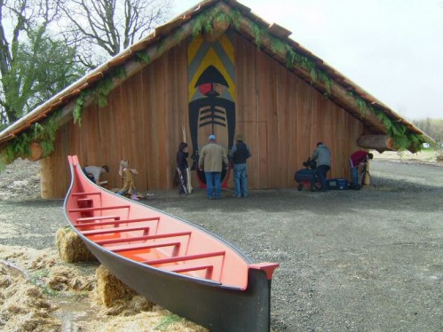
Figure 1. View of the complete Cathlapotle Plankhouse

Also, rehabilitation of the Jack Longstreet cabin on Ash Meadows National Wildlife Refuge in Nevada was completed in FY 2005 (Figure 2). The cabin is a unique example of pioneer resourcefulness, built from local stone and incorporating a spring mound into its structure. It was built in 1896 and is located beside one of Refuge’s warm water springs teeming with endangered pupfish. The restored cabin will be used as a visitor site to interpret key heritage resources and wildlife messages. The project, funded by a grant under the Southern Nevada Public Lands Management Act (SNPLMA), was completed largely by Refuge staff and volunteers. An open house is scheduled for the Fall of 2005.

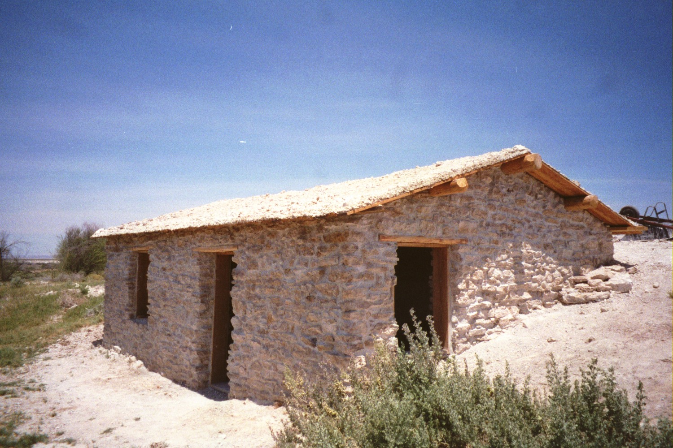
Figure 2. Jack Longstreet cabin on Ash Meadows National Wildlife Refuge in Nevada

The FWS has also recently begun working with the Travel Industry Association of America (TIA) to showcase the many and varied recreational and interpretive opportunities offered on refuges. The TIA is the largest organization providing information to both domestic and international travelers and travel agencies and makes a special point to focus on opportunities available on public lands.

The FWS also manages a portion of a National Historic Landmark lighthouse at Thacher Island National Wildlife Refuge (Figure 3). The Thacher Island Association interprets Thacher Island Lighthouse complex, including offering programs on heritage resources and wildlife. A new interpretive brochure and trail guide about Thacher Island was completed in FY 2005. The Thacher Island Association also received over $200,000 in grants for work on the National Historic Landmark; structures that are owned by the local town. Part of the funding came from the State of Massachusetts' Community Preservation Act.

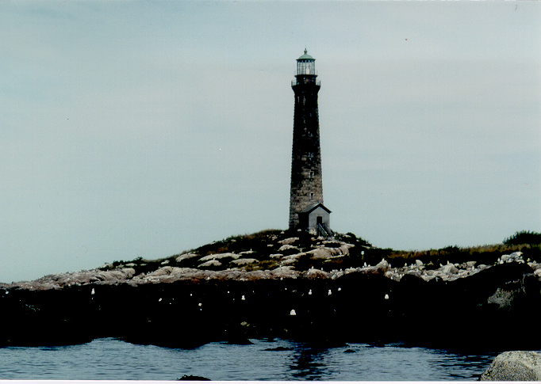

Figure 3. A view of a lighthouse located on Thacher Island National Wildlife Refuge. The lighthouse is part of a larger National Historic Landmark complex that the FWS co-manages.

The FWS nominated the Fish Hatchery 2 site for listing in the National Register of Historic Places. The site, located on Natchitoches National Fish Hatchery in Louisiana, contains important information on local habitat and its use. The nomination package is currently under review by the National Park Service for listing.

Volunteer Contributions

Many FWS heritage resource projects would not be completed without the assistance of our considerable volunteer corps. Information compiled for FY 2004 indicates that volunteers devoted 33,545 hours to heritage resource activities. We anticipate that volunteer contributions will increase in future years.

Visitor Programs and Community Economic Benefits

Over 400 national wildlife refuges and national fish hatcheries are open to the public. Many of these field stations offer interpretive and educational programs that include information about their local history and prehistory. Additionally, the FWS operates hundreds of visitor facilities that share information through exhibits and public programs.

The FWS recently completed an updated study on the economic benefits of national wildlife refuges and their programs to local communities (Banking on Nature: The Economic Benefits to Local Communities of National Wildlife Refuge Visitation - 2004, Division of Economics, FWS, Washington D.C.). The study clearly validates that communities near national wildlife refuges benefit economically from recreation-related tourism and other refuge programs. The study found visitors to national wildlife refuges generated almost $1.4 billion that went back into the local communities in the form of expenditures employment income (roughly $4 dollars for every appropriated dollar). The study noted that approximately 24,000 jobs were created as a result of recreation-related visitation.

III. Future Directions

The FWS’ new web page was used to co 2004 Preserve America report to help develop

(1) its new Cultural Resources website—an informational site that outlines the FWS heritage asset programs in detail for FWS employees as well as the general public (http://historicpreservation.fws.gov) ,

(2) input for the new Operational Plan being deployed FWS wide,

(3) in the formation of its new Museum Property sub-committee. Additional initiatives aimed at refining current Cultural Resource policies and handbooks are also being considered and will incorporate information derived for the Section 3 report as well as this update report.

Continuing Development

The FWS remains committed to offering its employees high-quality training for all its programs, including cultural resources. In FY2005 a class-room course was offered to Alaska Region employees. The course was tailored to the needs to the planning staff in that region, who have been focusing more on cultural resource needs as they develop and implement their Regional Comprehensive Conservation Plans. A similar course is being planned for the Pacific Region in early FY2006.

Additionally, a new cultural resources website was launched providing employees with training tools and guidance documents that can be used for day-to-day cultural resource activities. Updates to the website will occur in FY2006 as well.

Finally, the Headquarters cultural resource staff has begun working with NCTC to develop a web-based cultural resource training series for USFWS employees. The first module is under development and should be implemented after NCTC launches its new Learning Management System sometime in early 2006.

